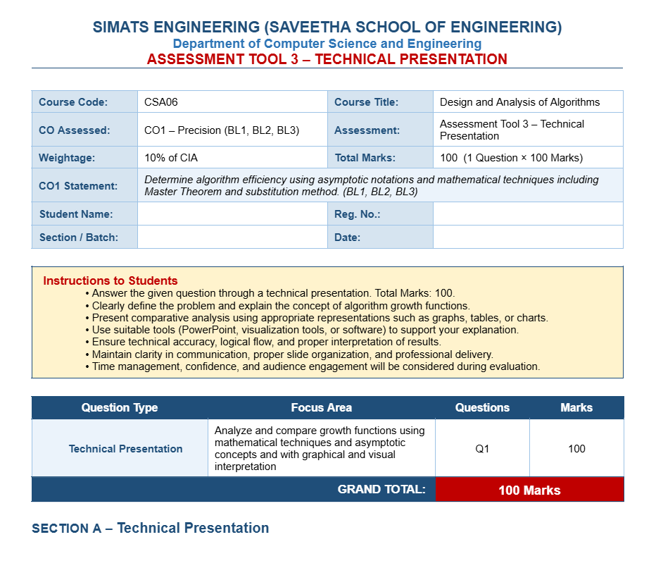
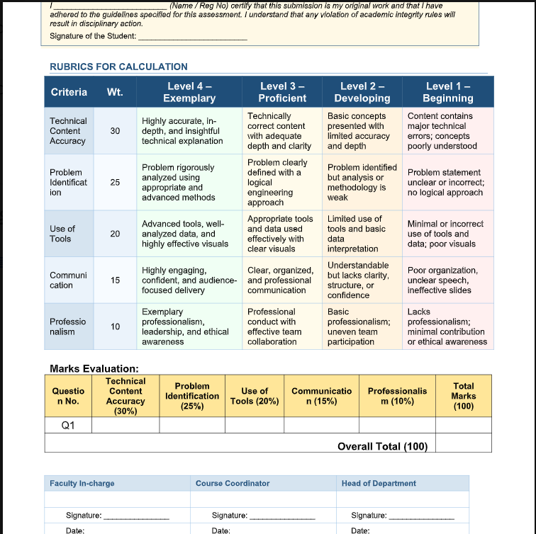

Q2. Master Theorem Application
Consider the recurrence relation T(n) = 2T(n/2) + n. Analyze the problem using the Master Theorem and
determine its time complexity. Clearly explain each case of the theorem and justify the selected case. Use tools
such as recursion tree diagrams for better understanding. Present the solution clearly with proper interpretation of
results.



